Home Page:

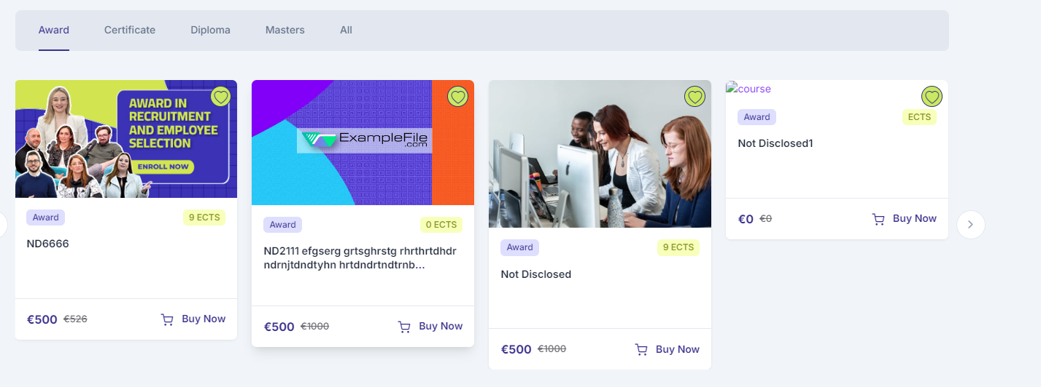



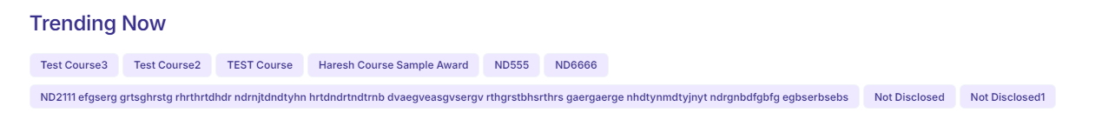



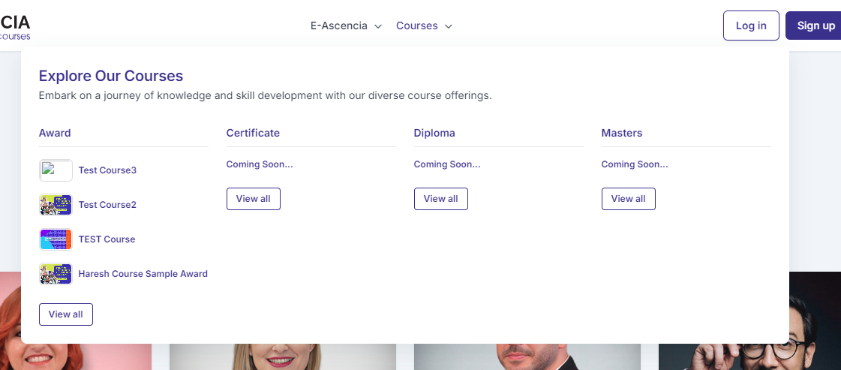



Embark on a knowledge and skill development journey with our diverse course offerings.

**Terms and Conditions Page:**



You can request a restriction on your data processing in specific situations.